First Airplane Trip

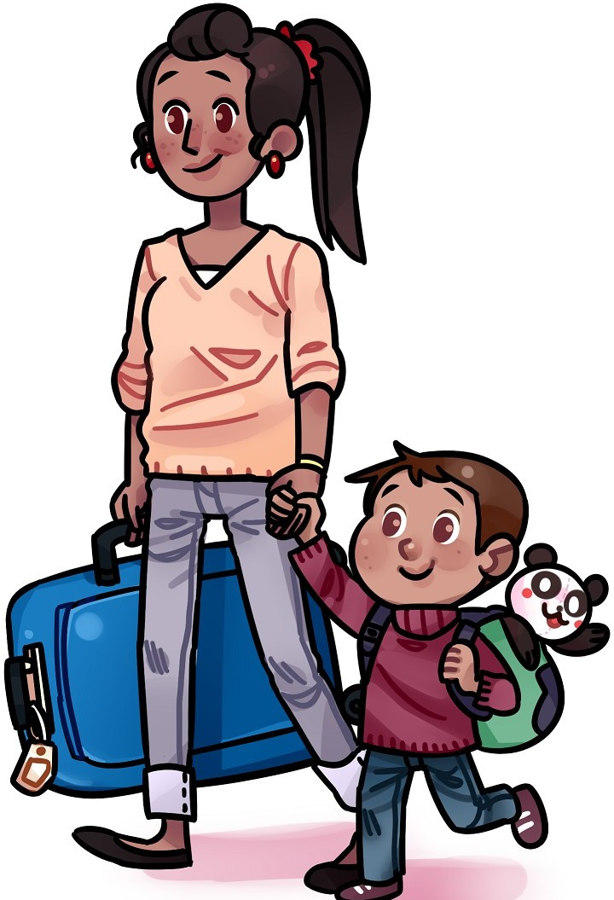Jake is going on a trip. He and Mom take a taxi to the airport. “It’s my first plane trip,” he tells the taxi driver.

“That’s great!” the taxi driver says. Jake rolls his suitcase onto the plane. “It’s my first plane trip,” he tells the pilot. “Welcome aboard,” the pilot says.

Jake finds his seat and buckles his seatbelt. The plane’s engines rumble and roar. Jake opens his backpack and pulls out Panda. “It’s my first plane trip,” he whispers. He holds Panda’s paw.

The plane moves faster and faster. Then—*Whoosh*! On the ground, cars and houses look like toys. Jake smiles. “Guess what, Panda?” he says. “Flying is fun!”